Carmen Leon
John Jay College of Criminal Justice
Capstone 2

- Is felony crime distributed evenly across days, months, and seasons in your borough?
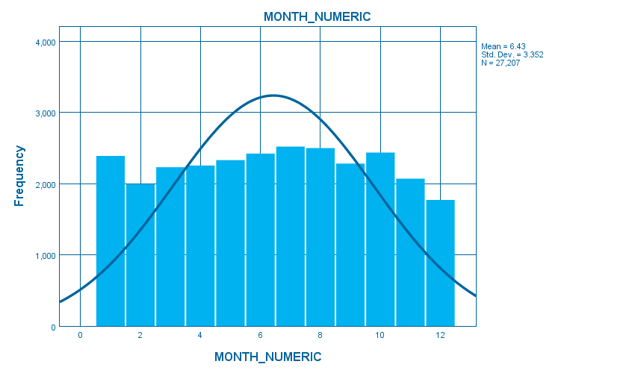
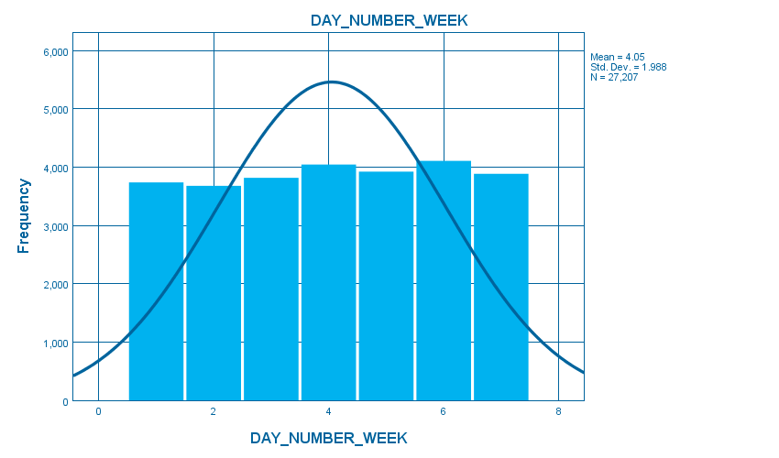

DAY_NUMBER_WEEKDAY_NUMBER_WEEK, table, 1 levels of column headers and 2 levels of row headers, table with 6 columns and 10 rows
 |  | Frequency | Percent | Valid Percent | Cumulative Percent
Valid | Sunday | 3740 | 13.7 | 13.7 | 13.7
Valid | Monday | 3681 | 13.5 | 13.5 | 27.3
Valid | Tuesday | 3819 | 14.0 | 14.0 | 41.3
Valid | Wednesday | 4047 | 14.9 | 14.9 | 56.2
Valid | Thursday | 3925 | 14.4 | 14.4 | 70.6
Valid | Friday | 4108 | 15.1 | 15.1 | 85.7
Valid | Saturday | 3887 | 14.3 | 14.3 | 100.0
Valid | Total | 27207 | 100.0 | 100.0
During the week the numbers of crimes are evenly distributed. On Mondays, Tuesdays, and Wednesdays the number of crimes is almost the same since the frequency does not differ with large margin. However the number of crimes increases as the weekend approaches, which is from Thursdays the number of crimes star to increase. On Thursday the frequency goes above 4000, which falls slightly on Fridays but later increase on Saturdays.
Across the months the number of crimes is also evenly distributed. The distribution is even as there are no months that has a very low frequency or months that has very high frequency with a large margin. January has a high frequency in the number of crimes which later decrease in February. From February the number of crimes increase, the increase is with a slight margin as it increases up to the July. From January up to July the frequency increases with slight margin from one month to another. However from July the number of crimes start to decrease up to December. Thus as it is shown the bar graph the number of crimes during the year is evenly distributed as there are no months where the crime is very high or very low from the rest of the months.

MONTH_NUMERICMONTH_NUMERIC, table, 1 levels of column headers and 2 levels of row headers, table with 6 columns and 15 rows
 |  | Frequency | Percent | Valid Percent | Cumulative Percent
Valid | January | 2390 | 8.8 | 8.8 | 8.8
Valid | February | 1994 | 7.3 | 7.3 | 16.1
Valid | March | 2232 | 8.2 | 8.2 | 24.3
Valid | April | 2255 | 8.3 | 8.3 | 32.6
Valid | May | 2331 | 8.6 | 8.6 | 41.2
Valid | June | 2422 | 8.9 | 8.9 | 50.1
Valid | July | 2521 | 9.3 | 9.3 | 59.3
Valid | August | 2500 | 9.2 | 9.2 | 68.5
Valid | September | 2283 | 8.4 | 8.4 | 76.9
Valid | October | 2437 | 9.0 | 9.0 | 85.9
Valid | November | 2070 | 7.6 | 7.6 | 93.5
Valid | December | 1772 | 6.5 | 6.5 | 100.0
Valid | Total | 27207 | 100.0 | 100.0

SEASON_NUMERICSEASON_NUMERIC, table, 1 levels of column headers and 2 levels of row headers, table with 6 columns and 7 rows
 |  | Frequency | Percent | Valid Percent | Cumulative Percent
Valid | Spring | 7011 | 25.8 | 25.8 | 25.8
Valid | Summer | 7495 | 27.5 | 27.5 | 53.3
Valid | Fall | 6498 | 23.9 | 23.9 | 77.2
Valid | Winter | 6203 | 22.8 | 22.8 | 100.0
Valid | Total | 27207 | 100.0 | 100.0

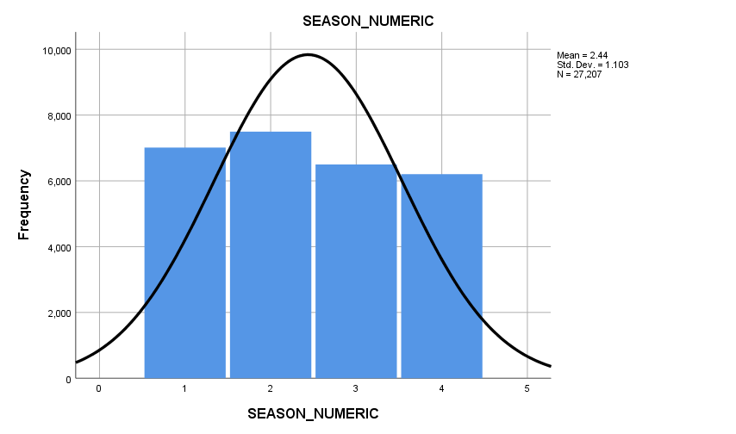

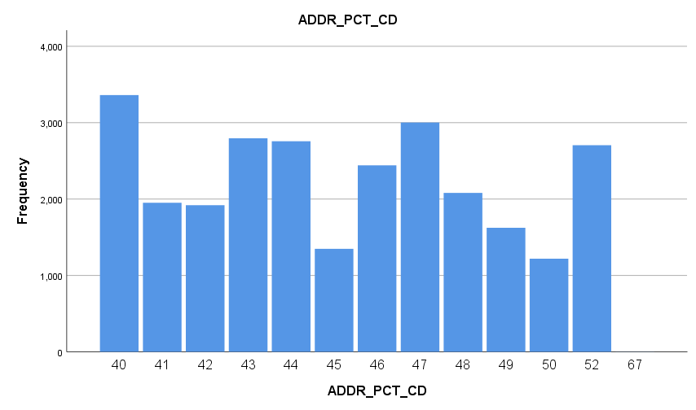

- Which precincts have the highest crime values?
ADDR_PCT_CDADDR_PCT_CD, table, 1 levels of column headers and 2 levels of row headers, table with 6 columns and 16 rows
 |  | Frequency | Percent | Valid Percent | Cumulative Percent
Valid | 40 | 3361 | 12.4 | 12.4 | 12.4
Valid | 41 | 1952 | 7.2 | 7.2 | 19.5
Valid | 42 | 1920 | 7.1 | 7.1 | 26.6
Valid | 43 | 2795 | 10.3 | 10.3 | 36.9
Valid | 44 | 2757 | 10.1 | 10.1 | 47.0
Valid | 45 | 1349 | 5.0 | 5.0 | 51.9
Valid | 46 | 2442 | 9.0 | 9.0 | 60.9
Valid | 47 | 3002 | 11.0 | 11.0 | 72.0
Valid | 48 | 2080 | 7.6 | 7.6 | 79.6
Valid | 49 | 1624 | 6.0 | 6.0 | 85.6
Valid | 50 | 1219 | 4.5 | 4.5 | 90.1
Valid | 52 | 2705 | 9.9 | 9.9 | 100.0
Valid | 67 | 1 | .0 | .0 | 100.0
Valid | Total | 27207 | 100.0 | 100.0

From the graph above, precinct 40 has the highest values of crimes. It has a frequency of 3361 which is the highest value in all the precincts.

- Are certain felony crimes seasonal? What crimes show an increase in warmer seasons?
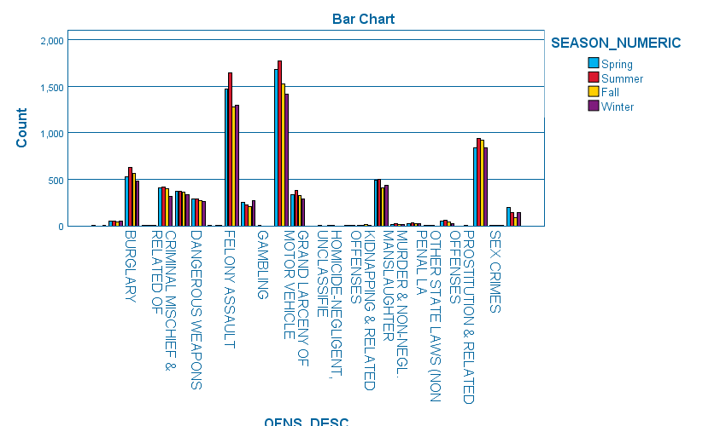
Felony assault crimes are seasonal. During summer the number of felony assaults increase with a very high range. Whereas during winter the crimes are not as high as during summer. Thus during the warmer season which is summer the number of crimes are very high due to the increase. In the graph below the number of felony crimes in winter is 1299 while during spring it increases to 1474 and later during summer it increases to 1644. Thus the crimes increase during the warmer season.

OFNS_DESC * SEASON_NUMERIC CrosstabulationOFNS_DESC * SEASON_NUMERIC Crosstabulation, table, Count, 1 layers, 2 levels of column headers and 2 levels of row headers, table with 7 columns and 31 rows
Count

 |  | SEASON_NUMERIC |  |  |  | Total
 |  | Spring | Summer | Fall | Winter | Total
OFNS_DESC |  | 2 | 0 | 0 | 1 | 3
OFNS_DESC | ARSON | 51 | 55 | 46 | 48 | 200
OFNS_DESC | BURGLARY | 529 | 628 | 566 | 485 | 2208
OFNS_DESC | CHILD ABANDONMENT/NON SUPPORT | 2 | 1 | 1 | 1 | 5
OFNS_DESC | CRIMINAL MISCHIEF & RELATED OF | 407 | 413 | 398 | 314 | 1532
OFNS_DESC | DANGEROUS DRUGS | 370 | 370 | 361 | 332 | 1433
OFNS_DESC | DANGEROUS WEAPONS | 287 | 293 | 272 | 258 | 1110
OFNS_DESC | ENDAN WELFARE INCOMP | 1 | 0 | 1 | 1 | 3
OFNS_DESC | FELONY ASSAULT | 1474 | 1644 | 1279 | 1299 | 5696
OFNS_DESC | FORGERY | 250 | 223 | 206 | 267 | 946
OFNS_DESC | GAMBLING | 1 | 0 | 0 | 0 | 1
OFNS_DESC | GRAND LARCENY | 1679 | 1768 | 1525 | 1417 | 6389
OFNS_DESC | GRAND LARCENY OF MOTOR VEHICLE | 331 | 384 | 328 | 285 | 1328
OFNS_DESC | HOMICIDE-NEGLIGENT-VEHICLE | 0 | 0 | 0 | 1 | 1
OFNS_DESC | HOMICIDE-NEGLIGENT,UNCLASSIFIE | 0 | 1 | 1 | 0 | 2
OFNS_DESC | KIDNAPPING | 0 | 2 | 1 | 2 | 5
OFNS_DESC | KIDNAPPING & RELATED OFFENSES | 5 | 6 | 11 | 6 | 28
OFNS_DESC | MISCELLANEOUS PENAL LAW | 494 | 502 | 408 | 438 | 1842
OFNS_DESC | MURDER & NON-NEGL. MANSLAUGHTER | 11 | 23 | 18 | 15 | 67
OFNS_DESC | NYS LAWS-UNCLASSIFIED FELONY | 27 | 37 | 26 | 26 | 116
OFNS_DESC | OTHER STATE LAWS (NON PENAL LA | 1 | 1 | 1 | 0 | 3
OFNS_DESC | POSSESSION OF STOLEN PROPERTY | 52 | 60 | 38 | 28 | 178
OFNS_DESC | PROSTITUTION & RELATED OFFENSES | 0 | 0 | 1 | 0 | 1
OFNS_DESC | ROBBERY | 837 | 937 | 924 | 835 | 3533
OFNS_DESC | SEX CRIMES | 6 | 6 | 2 | 2 | 16
OFNS_DESC | THEFT-FRAUD | 194 | 141 | 84 | 142 | 561
Total |  | 7011 | 7495 | 6498 | 6203 | 27207

- Is felony crime distributed evenly across times of day? Which time of day had the highest felony incidents?
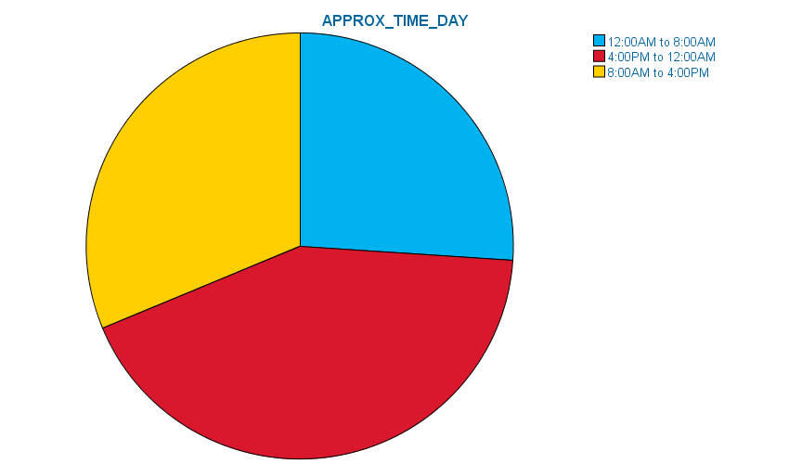
APPROX_TIME_DAYAPPROX_TIME_DAY, table, 1 levels of column headers and 2 levels of row headers, table with 6 columns and 6 rows
 |  | Frequency | Percent | Valid Percent | Cumulative Percent
Valid | 12:00AM to 8:00AM | 7098 | 26.1 | 26.1 | 26.1
Valid | 4:00PM to 12:00AM | 11601 | 42.6 | 42.6 | 68.7
Valid | 8:00AM to 4:00PM | 8508 | 31.3 | 31.3 | 100.0
Valid | Total | 27207 | 100.0 | 100.0

From the pie chart above it shows that felony crime is evenly distribute during the day. However from 4:00om to 12:00am the number of crimes are high compared to the other times during the day. From 12:00 am to 8:00 am the felony crimes frequency is 7098 while during 8:00 am to 4:00 pm the crime frequency is 8508. Thus in the evening time the number of crimes is high.

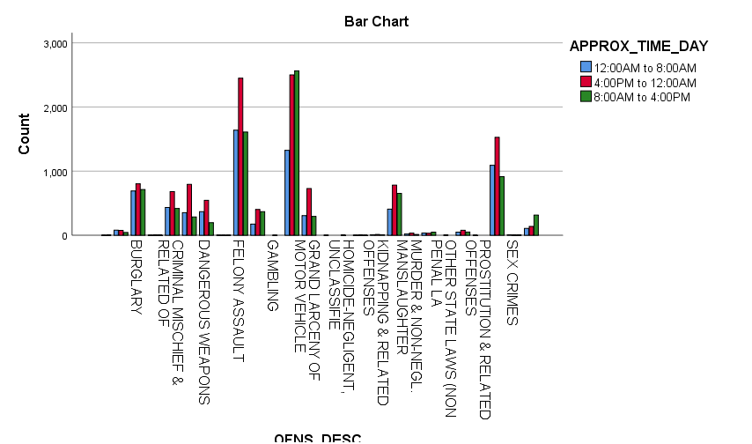
- Do certain felony crimes occur more frequently during certain times of day?
More felony crimes occur during the evening and at night. From 4:00pm to 12:00 am the number of felony crimes increases with a large margin. Most of the crimes take place at this time, which is from evening to midnight.

OFNS_DESC * APPROX_TIME_DAY CrosstabulationOFNS_DESC * APPROX_TIME_DAY Crosstabulation, table, Count, 1 layers, 2 levels of column headers and 2 levels of row headers, table with 6 columns and 31 rows
Count

 |  | APPROX_TIME_DAY |  |  | Total
 |  | 12:00AM to 8:00AM | 4:00PM to 12:00AM | 8:00AM to 4:00PM | Total
OFNS_DESC |  | 0 | 1 | 2 | 3
OFNS_DESC | ARSON | 80 | 77 | 43 | 200
OFNS_DESC | BURGLARY | 691 | 803 | 714 | 2208
OFNS_DESC | CHILD ABANDONMENT/NON SUPPORT | 1 | 2 | 2 | 5
OFNS_DESC | CRIMINAL MISCHIEF & RELATED OF | 433 | 681 | 418 | 1532
OFNS_DESC | DANGEROUS DRUGS | 353 | 794 | 286 | 1433
OFNS_DESC | DANGEROUS WEAPONS | 369 | 545 | 196 | 1110
OFNS_DESC | ENDAN WELFARE INCOMP | 1 | 1 | 1 | 3
OFNS_DESC | FELONY ASSAULT | 1638 | 2449 | 1609 | 5696
OFNS_DESC | FORGERY | 174 | 403 | 369 | 946
OFNS_DESC | GAMBLING | 0 | 1 | 0 | 1
OFNS_DESC | GRAND LARCENY | 1325 | 2500 | 2564 | 6389
OFNS_DESC | GRAND LARCENY OF MOTOR VEHICLE | 306 | 728 | 294 | 1328
OFNS_DESC | HOMICIDE-NEGLIGENT-VEHICLE | 0 | 1 | 0 | 1
OFNS_DESC | HOMICIDE-NEGLIGENT,UNCLASSIFIE | 0 | 2 | 0 | 2
OFNS_DESC | KIDNAPPING | 1 | 3 | 1 | 5
OFNS_DESC | KIDNAPPING & RELATED OFFENSES | 7 | 13 | 8 | 28
OFNS_DESC | MISCELLANEOUS PENAL LAW | 407 | 782 | 653 | 1842
OFNS_DESC | MURDER & NON-NEGL. MANSLAUGHTER | 20 | 34 | 13 | 67
OFNS_DESC | NYS LAWS-UNCLASSIFIED FELONY | 36 | 31 | 49 | 116
OFNS_DESC | OTHER STATE LAWS (NON PENAL LA | 0 | 3 | 0 | 3
OFNS_DESC | POSSESSION OF STOLEN PROPERTY | 49 | 78 | 51 | 178
OFNS_DESC | PROSTITUTION & RELATED OFFENSES | 1 | 0 | 0 | 1
OFNS_DESC | ROBBERY | 1091 | 1527 | 915 | 3533
OFNS_DESC | SEX CRIMES | 8 | 3 | 5 | 16
OFNS_DESC | THEFT-FRAUD | 107 | 139 | 315 | 561
Total |  | 7098 | 11601 | 8508 | 27207

- How many crimes were completed? How many crimes were attempted?
They were 26197 completed and attempted crimes were 1010 with a percentage of 96.3 of 3.7 respectively.
CRM_ATPT_CPTD_CDCRM_ATPT_CPTD_CD, table, 1 levels of column headers and 2 levels of row headers, table with 6 columns and 5 rows
 |  | Frequency | Percent | Valid Percent | Cumulative Percent
Valid | ATTEMPTED | 1010 | 3.7 | 3.7 | 3.7
Valid | COMPLETED | 26197 | 96.3 | 96.3 | 100.0
Valid | Total | 27207 | 100.0 | 100.0

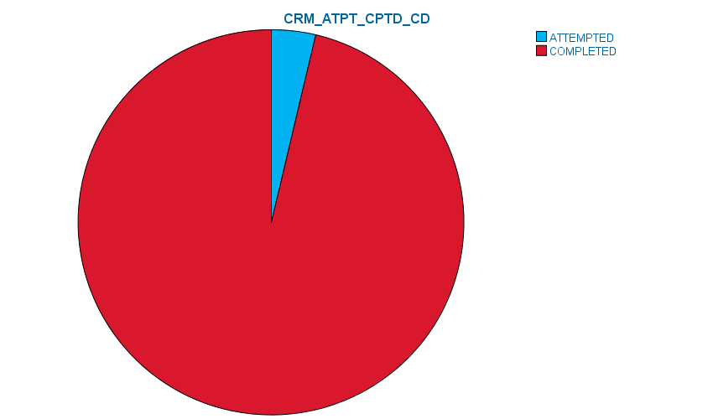

7. Which agencies are performing law enforcement activities in your borough?
The highest one is being done by N.Y. Police which is 86.6%, 7.4 % is being done by N.Y. Housing Police, the second lowest one is N.Y. Transit Police by 3.5%. Lastly the lowest is 1.9% done by department of corrections.
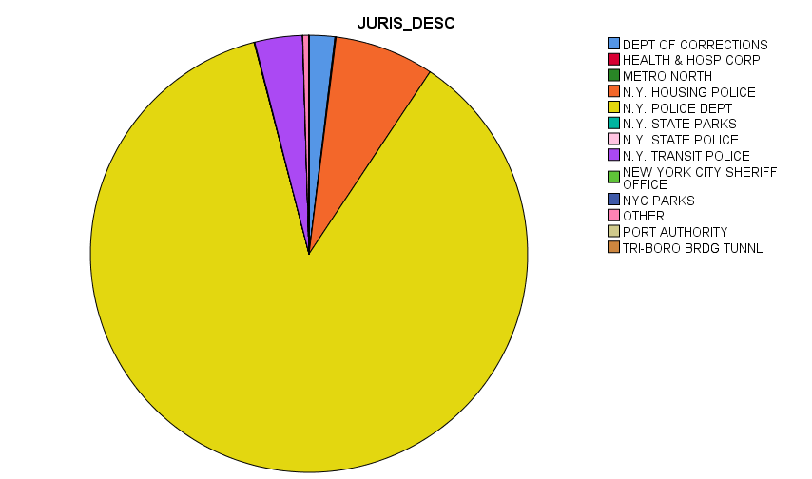

JURIS_DESCJURIS_DESC, table, 1 levels of column headers and 2 levels of row headers, table with 6 columns and 16 rows
 |  | Frequency | Percent | Valid Percent | Cumulative Percent
Valid | DEPT OF CORRECTIONS | 517 | 1.9 | 1.9 | 1.9
Valid | HEALTH & HOSP CORP | 22 | .1 | .1 | 2.0
Valid | METRO NORTH | 2 | .0 | .0 | 2.0
Valid | N.Y. HOUSING POLICE | 2000 | 7.4 | 7.4 | 9.3
Valid | N.Y. POLICE DEPT | 23565 | 86.6 | 86.6 | 96.0
Valid | N.Y. STATE PARKS | 7 | .0 | .0 | 96.0
Valid | N.Y. STATE POLICE | 8 | .0 | .0 | 96.0
Valid | N.Y. TRANSIT POLICE | 957 | 3.5 | 3.5 | 99.5
Valid | NEW YORK CITY SHERIFF OFFICE | 2 | .0 | .0 | 99.5
Valid | NYC PARKS | 2 | .0 | .0 | 99.5
Valid | OTHER | 120 | .4 | .4 | 100.0
Valid | PORT AUTHORITY | 1 | .0 | .0 | 100.0
Valid | TRI-BORO BRDG TUNNL | 4 | .0 | .0 | 100.0
Valid | Total | 27207 | 100.0 | 100.0

W8. What were some of the types and amounts of offenses the agencies were involved in investigating?
OFNS_DESC * JURIS_DESC CrosstabulationOFNS_DESC * JURIS_DESC Crosstabulation, table, Count, 1 layers, 2 levels of column headers and 2 levels of row headers, table with 16 columns and 31 rows
Count

 |  | JURIS_DESC |  |  |  |  |  |  |  |  |  |  |  |  | Total
 |  | DEPT OF CORRECTIONS | HEALTH & HOSP CORP | METRO NORTH | N.Y. HOUSING POLICE | N.Y. POLICE DEPT | N.Y. STATE PARKS | N.Y. STATE POLICE | N.Y. TRANSIT POLICE | NEW YORK CITY SHERIFF OFFICE | NYC PARKS | OTHER | PORT AUTHORITY | TRI-BORO BRDG TUNNL | Total
OFNS_DESC |  | 0 | 0 | 0 | 0 | 3 | 0 | 0 | 0 | 0 | 0 | 0 | 0 | 0 | 3
OFNS_DESC | ARSON | 8 | 0 | 0 | 81 | 54 | 0 | 0 | 0 | 0 | 0 | 57 | 0 | 0 | 200
OFNS_DESC | BURGLARY | 0 | 0 | 0 | 116 | 2085 | 0 | 0 | 5 | 0 | 0 | 2 | 0 | 0 | 2208
OFNS_DESC | CHILD ABANDONMENT/NON SUPPORT | 0 | 0 | 0 | 0 | 5 | 0 | 0 | 0 | 0 | 0 | 0 | 0 | 0 | 5
OFNS_DESC | CRIMINAL MISCHIEF & RELATED OF | 9 | 0 | 1 | 119 | 1251 | 1 | 0 | 145 | 0 | 0 | 6 | 0 | 0 | 1532
OFNS_DESC | DANGEROUS DRUGS | 1 | 1 | 0 | 127 | 1278 | 0 | 3 | 11 | 1 | 1 | 10 | 0 | 0 | 1433
OFNS_DESC | DANGEROUS WEAPONS | 0 | 0 | 0 | 147 | 921 | 0 | 0 | 41 | 0 | 0 | 0 | 0 | 1 | 1110
OFNS_DESC | ENDAN WELFARE INCOMP | 0 | 0 | 0 | 0 | 3 | 0 | 0 | 0 | 0 | 0 | 0 | 0 | 0 | 3
OFNS_DESC | FELONY ASSAULT | 272 | 13 | 0 | 589 | 4730 | 0 | 1 | 60 | 1 | 1 | 28 | 0 | 1 | 5696
OFNS_DESC | FORGERY | 0 | 0 | 1 | 38 | 606 | 2 | 2 | 296 | 0 | 0 | 0 | 0 | 1 | 946
OFNS_DESC | GAMBLING | 0 | 0 | 0 | 0 | 1 | 0 | 0 | 0 | 0 | 0 | 0 | 0 | 0 | 1
OFNS_DESC | GRAND LARCENY | 1 | 7 | 0 | 228 | 5853 | 0 | 0 | 292 | 0 | 0 | 8 | 0 | 0 | 6389
OFNS_DESC | GRAND LARCENY OF MOTOR VEHICLE | 0 | 0 | 0 | 40 | 1288 | 0 | 0 | 0 | 0 | 0 | 0 | 0 | 0 | 1328
OFNS_DESC | HOMICIDE-NEGLIGENT-VEHICLE | 0 | 0 | 0 | 0 | 1 | 0 | 0 | 0 | 0 | 0 | 0 | 0 | 0 | 1
OFNS_DESC | HOMICIDE-NEGLIGENT,UNCLASSIFIE | 0 | 0 | 0 | 0 | 2 | 0 | 0 | 0 | 0 | 0 | 0 | 0 | 0 | 2
OFNS_DESC | KIDNAPPING | 0 | 0 | 0 | 0 | 5 | 0 | 0 | 0 | 0 | 0 | 0 | 0 | 0 | 5
OFNS_DESC | KIDNAPPING & RELATED OFFENSES | 0 | 0 | 0 | 3 | 25 | 0 | 0 | 0 | 0 | 0 | 0 | 0 | 0 | 28
OFNS_DESC | MISCELLANEOUS PENAL LAW | 208 | 0 | 0 | 194 | 1418 | 0 | 2 | 12 | 0 | 0 | 6 | 1 | 1 | 1842
OFNS_DESC | MURDER & NON-NEGL. MANSLAUGHTER | 0 | 0 | 0 | 9 | 58 | 0 | 0 | 0 | 0 | 0 | 0 | 0 | 0 | 67
OFNS_DESC | NYS LAWS-UNCLASSIFIED FELONY | 0 | 1 | 0 | 8 | 104 | 3 | 0 | 0 | 0 | 0 | 0 | 0 | 0 | 116
OFNS_DESC | OTHER STATE LAWS (NON PENAL LA | 0 | 0 | 0 | 0 | 3 | 0 | 0 | 0 | 0 | 0 | 0 | 0 | 0 | 3
OFNS_DESC | POSSESSION OF STOLEN PROPERTY | 0 | 0 | 0 | 8 | 166 | 0 | 0 | 3 | 0 | 0 | 1 | 0 | 0 | 178
OFNS_DESC | PROSTITUTION & RELATED OFFENSES | 0 | 0 | 0 | 0 | 1 | 0 | 0 | 0 | 0 | 0 | 0 | 0 | 0 | 1
OFNS_DESC | ROBBERY | 2 | 0 | 0 | 245 | 3191 | 1 | 0 | 92 | 0 | 0 | 2 | 0 | 0 | 3533
OFNS_DESC | SEX CRIMES | 16 | 0 | 0 | 0 | 0 | 0 | 0 | 0 | 0 | 0 | 0 | 0 | 0 | 16
OFNS_DESC | THEFT-FRAUD | 0 | 0 | 0 | 48 | 513 | 0 | 0 | 0 | 0 | 0 | 0 | 0 | 0 | 561
Total |  | 517 | 22 | 2 | 2000 | 23565 | 7 | 8 | 957 | 2 | 2 | 120 | 1 | 4 | 27207

The department of corrections was involved in felony assault crimes and miscellanies penal laws crimes. They committed 272 felony assaults. They committed 204 miscelleouns crime laws.
The New York housing department was involved in arson crimes, burglary, and drugs crimes. Felony assault, forgery and robbery.
The New York police department was involved in the heist number of crimes. It was involved in 2085 crimes of burglary, 1278 crimes in drugs, 1288 grand larceny of motor vehicle and 1488 miscellaneous penal law.

